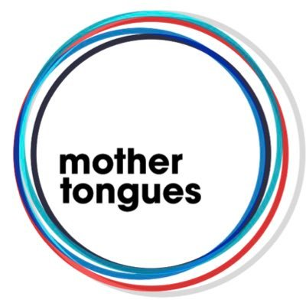

Application form for the
Mother Tongues Award 2020

Please read through the guidelines on www.mother-tongues-films.co.uk/apply before making an application.

If you have any queries or general enquiries regarding the application process, guidelines or application form please contact us: mothertonguesfilms@gmail.com

1. About Yourself

Full name of lead applicant
Role of lead applicant (writer, director or writer/director)

Phone Number
Email Address
UK address and postcode
Other team members, additional writers or director only (max 3 team members)
It is not a requirement to have a producer attached to the project, but if you are working with one please specify their name.

2. The Project

Project title
Where in the UK is the story mainly set?
Project synopsis (300 words max)
What language(s) is your story in and why? (300 words max)
Please specify if you speak the language(s) and why you want to tell this story in this language.

Story outline (1500 words min)
You do not need to write a story outline if you already have a longer treatment or a full screenplay draft that you would like us to consider as part of your application. If so, please email it alongside the application form.

Biography and filmography of applicant (1000 words max)
Please specify at least 1 work that makes you eligible for the scheme (the full list is available on the website) and include a link to at least 1 work.
If you're applying as a writer and director team, please include both biographies. In this case, it is at least the director who must meet the entry requirements, or preferably both applicants.

